24 May 2025
Theme: Jesus’s authoritative word

Songs:
- My hope is built
- You are my all in all
- Kids: To Be Like Jesus
- Pre-sermon: In this book
- Closing: Trust and Obey

Verse 1:
Intro:
G A F#/D G x2

G A
My hope is built on nothing less
Em G
Than Jesus' blood and righteousness
G A
I dare not trust the sweetest frame
Em G
But wholly lean on Jesus' name

Chorus:
D Em
On Christ the solid rock I stand
F#/D G A
All other ground is sinking sand
Bm A G A F#/D G
All other ground is sinking sand

G A F#/D G

Verse 2:
G A
When darkness seems to hide his face
Em G
I rest on his unchanging grace
G A
In every high and stormy gale
Em G
My anchor holds within the veil

CHORUS

Verse 3:
G A
His oath, his covenant, his blood
Em G
Support me in the whelming flood
G A
When all around my soul gives way
Em G
He then is all my hope and stay

CHORUS

Verse 4:
D D
When he shall come with trumpet sound
D Bm
Oh may I then in him be found
D D
Dressed in his righteousness alone
D G
Faultless to stand before the throne

CHORUS

You are my all in all

Intro:
E B C#m G#m A B E

[Verse 1]
E B C#m
You are my strength when I am weak
G#m A
You are the treasure that I seek
E B E B
You are my all in all

E B C#m
Seeking You as a precious jewel
G#m A
Lord to give up, I'd be a fool
B E B
You are my all in all

[Chorus]
E B C#m G#m A B E B
Jesus, Lamb of God, worthy is Your name
E B C#m G#m A B E
Jesus, Lamb of God, worthy is Your name

[Verse 2]
E B C#m
Taking my sin, my cross, my shame
G#m A
Rising again, I bless Your name
B E B
You are my all in all

E B C#m
When I fall down, You pick me up
G#m A
When I am dry, You fill my cup
E B E B
You are my all in all

CHORUS x2

A B E
Worthy is Your name

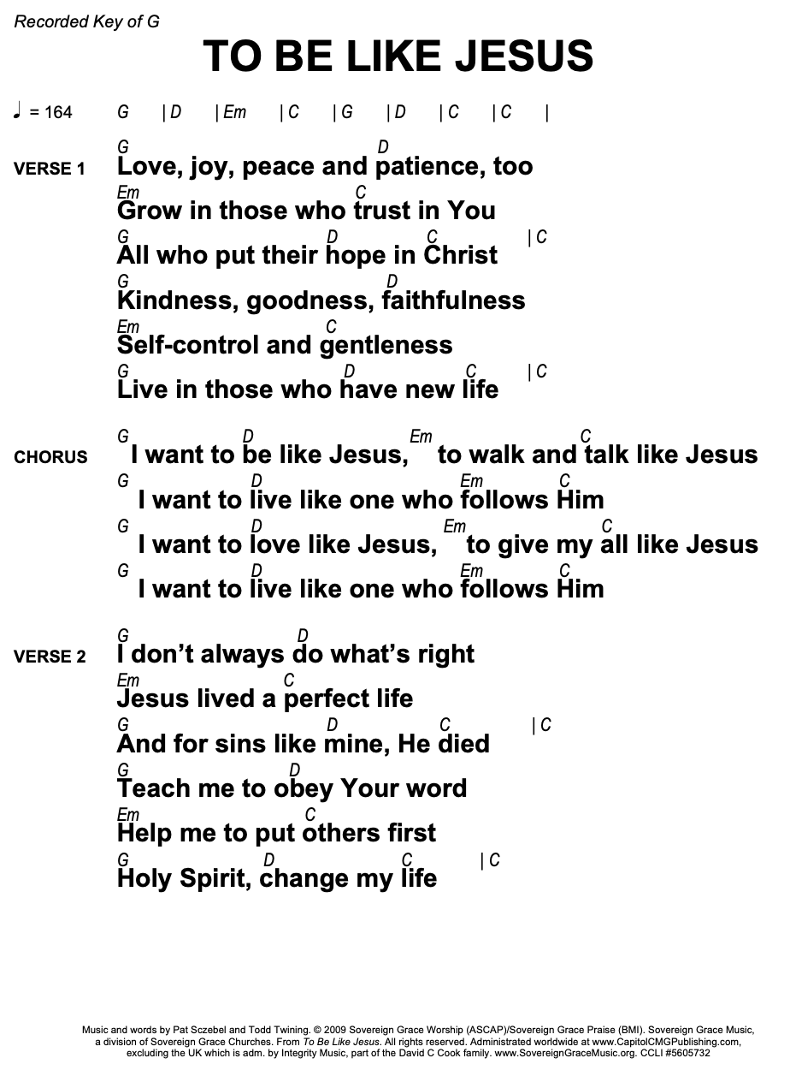

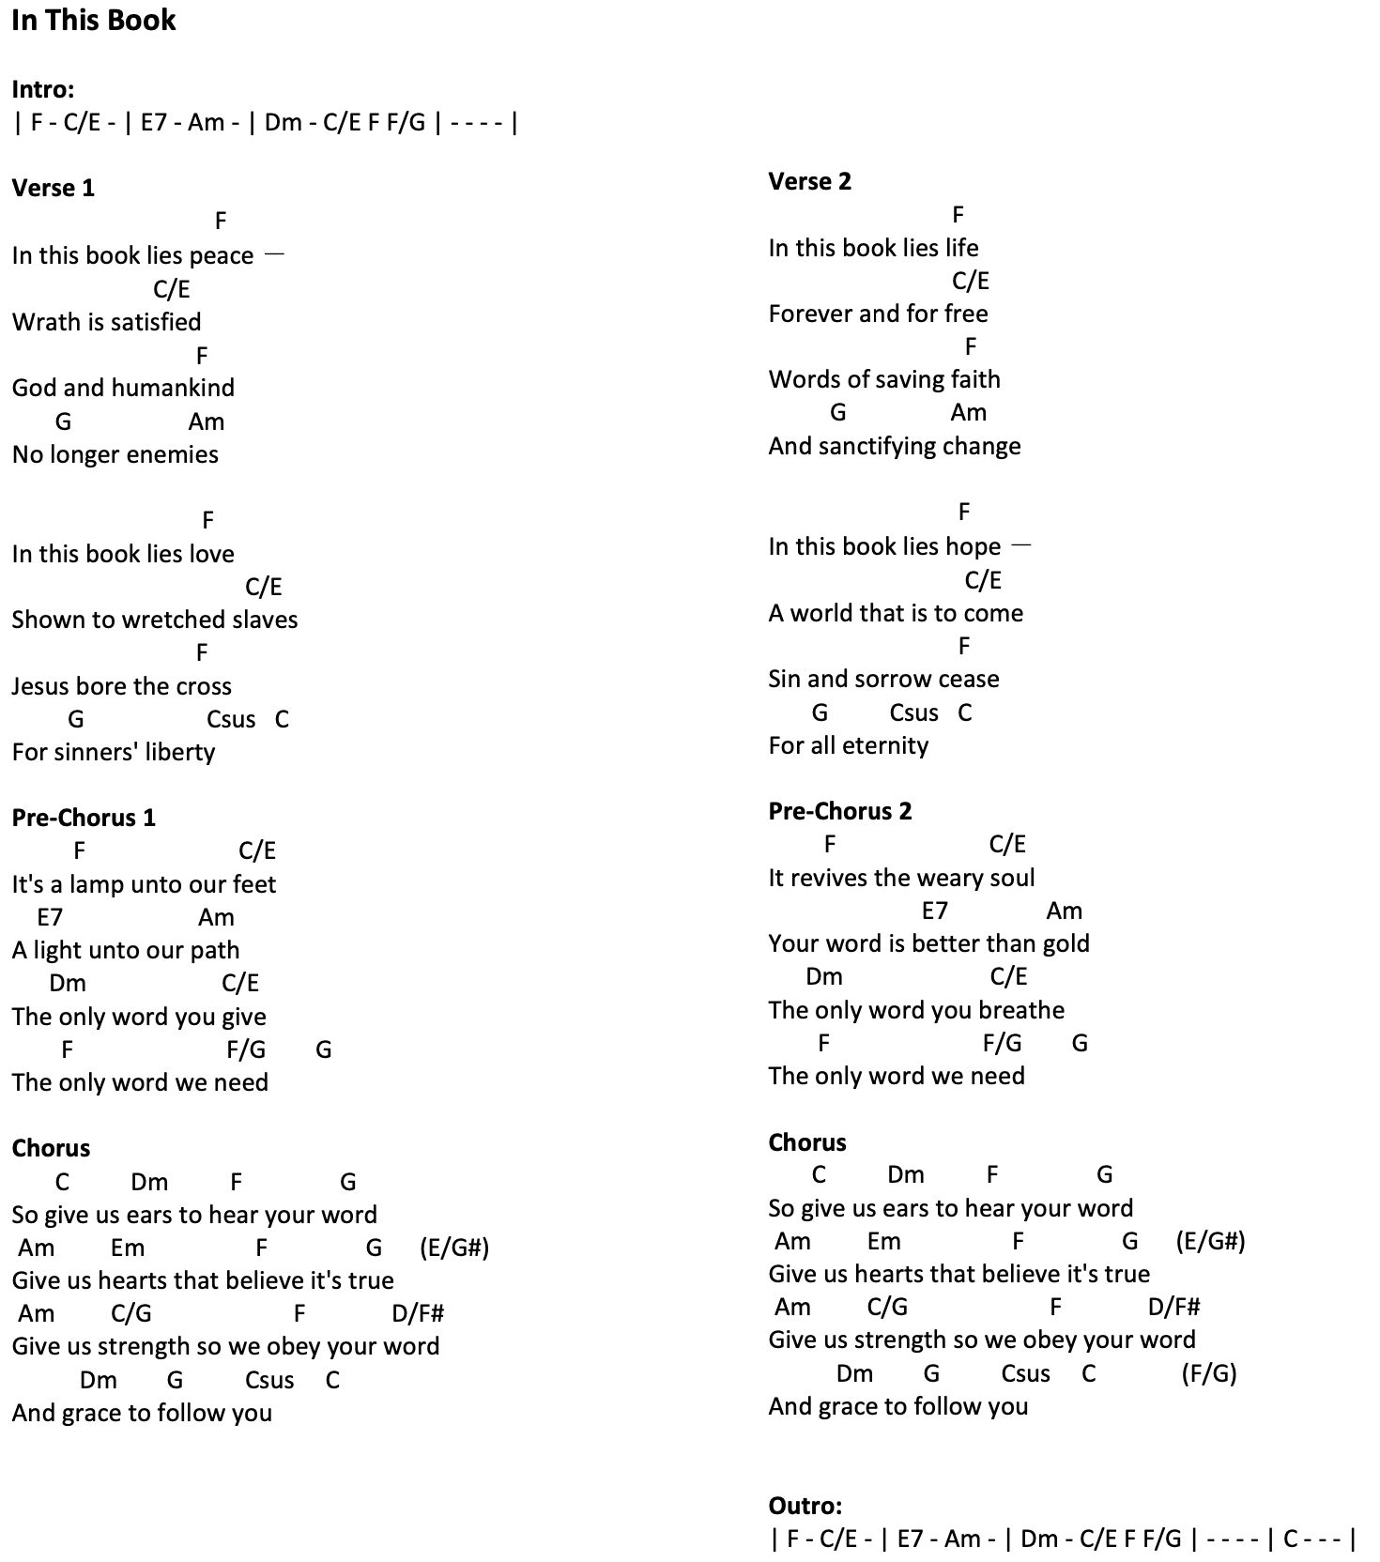
Trust and Obey Don Moen

Verse 1:
D A7 D
When we walk with the Lord
A7 D
In the light of His Word
G D A A7
What a glory He sheds on our way
D A7 D
While we do His good will
A7 D
He abides with us still
G D A7 D
And with all who will trust and, o-bey

Refrain:
A7 D
Trust and obey
B7 Em
For there’s no other way
A7 D
To be happy in Jesus
A7 A7 D
But to trust and o-bey

D C# Bm A G A A

Verse 2:
D A7 D
Not a shadow can rise,
A7 D
Not a cloud in the skies,
G D A A7
But his smile quickly drives it away,-
D A7 D
Not a doubt nor a fear,
A7 D
Not a sigh nor a tear
G D A7 D
Can abide while we trust and obey.

REFRAIN

Verse 3:
D A7 D
Not a burden we bear,
A7 D
Not a sorrow we share,
G D A A7
But our toil he doth richly repay;
D A7 D
Not a grief nor a loss,
A7 D
Not a frown nor a cross,
G D A7 D
But is blest if we trust and obey.

REFRAIN

Verse 3:
D A7 D
But we never can prove
A7 D
The delights of His love
G D A A7
Until all on the altar we lay
D A7 D
For the favor He shows
A7 D
And the joy He bestows
G D A7 D
Are for them who will trust and o-bey

REFRAIN

Verse 4:
D A7 D
Then in fellowship sweet
A7 D
We will sit at His feet
G D A A7
Or we’ll walk by His side in the way
D A7 D
What He says we will do
A7 D
Where He sends we will go
G D A7 D
Never fear, only trust and o-bey

REFRAIN

